Name: Ryoji Araki

**INEG 33103 - Probability and Statistics**

**Week 2 Homework (100 points)**

**Question 1.** Decide whether a discrete or continuous random variable is the best model for each of the following variables.

**1 (p61, 3-1).** The lifetime of a biomedical device after implant in a patient.

* **Continuous**

**2 (p61,3-2).** The number of times a transistor in a computer memory changes state in a time interval.

* **Discrete**

**3 (p61,3-3).** The strength of a concrete specimen.

* **Continuous**

**4 (p61,3-4).** The number of convenience options selected by an automobile buyer.

* **Discrete**

**5 (p61,3-9).** The concentration of organic solids in a water sample.

* **Continuous**

**Question 2 (p65, 3-18).** Let $X$ denote the number of patients who suffer an infection within a floor of a hospital per month with the following probabilities:

|  |  |  |  |  |
| --- | --- | --- | --- | --- |
| $$x$$ | 0 | 1 | 2 | 3 |
| $$P(X =x)$$ | 0.7 | 0.15 | 0.1 | 0.05 |

Determine the following probabilities:

1. Less than one infection: P(X<1) = 0.7

**b)** More than three infections: P(X>3) = 0

**c)** No infections: P(X==0) = 0.7

**Question 3 (p108, 3-106**). An electronic product contains 40 integrated circuits. The probability that any integrated circuit is defective is 0.01, and the integrated circuits are independent. The product operates only if there are no defective integrated circuits. What is the probability that the product operates?

* P(X==0) = C(40, 0) * (0.99)^40 * (0.01)^0 = 0.6689717585696803

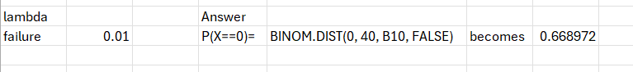

**Question 4 (p117, 3-124).** The number of earthquake tremors in a 12-month period appears to be distributed as a Poisson random variable with a mean of 6. Assume the number of tremors from one 12-month period is independent of the number in the next 12-month period.

1. What is the probability that there are 10 tremors in 1 year?

-> P(X==10) = 6^10 / (e^6 * 10!) = 0.04130309341233774

**b)** What is the probability that there are 18 tremors in 2 years?

-> P(X==18, λ=12) = 12^18 / (e^12 * 18!) = 0.025549807110578374

**c)** What is the probability that there are no tremors in a 1-month period?

-> P(X==0, λ=1/2) = (1/2)^0 / (e^(1/2) * 0!) = 0.6065306597126334

**d)** What is the probability that there are more than 5 tremors in a 6-month period?

**->** P(X>5, λ=3) = 1-sum(i, 3^i / (e^3 * i!)) = 0.083918

